# **Data Preparation**

## **Recap of Fundamentals of Machine Learning**

## **Regression vs. Classification**

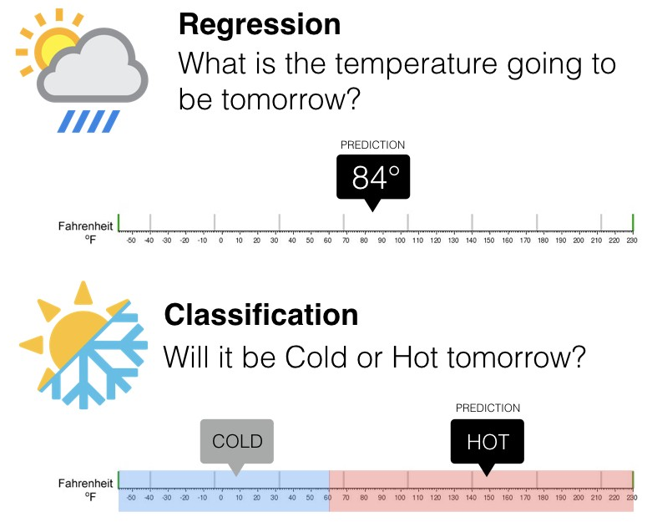

### **The Sklearn modelling workflow**

**from** **sklearn.some_module** **import** SomeModel

model = SomeModel()

model.fit(X_train,y_train)

model.score(X_test,y_test)

model.predict(X_new)

### **The Holdout Method**

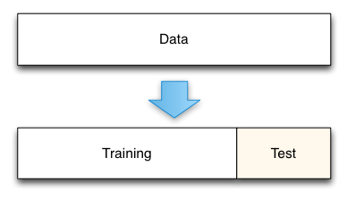

### **The Holdout Method - Dataframe view**

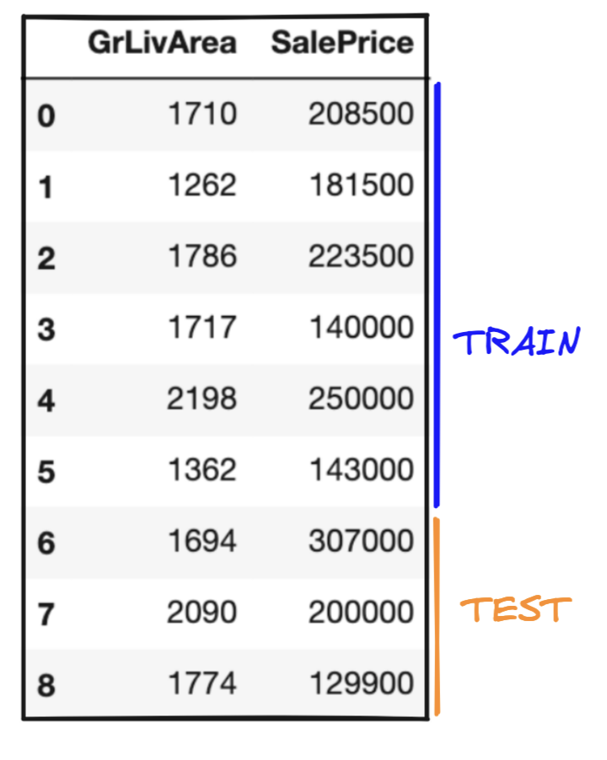

### **The Holdout Method in Scikit-Learn**

**from** **sklearn.model_selection** **import** train_test_split

X_train, X_test, y_train, y_test = train_test_split(X, y, test_size=0.3, random_state=88)

## **K-Fold Cross validation**

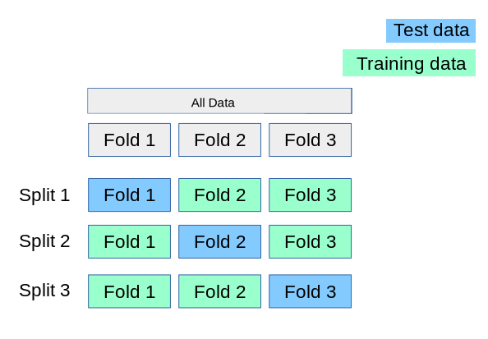

### **Cross validation - Dataframe view**

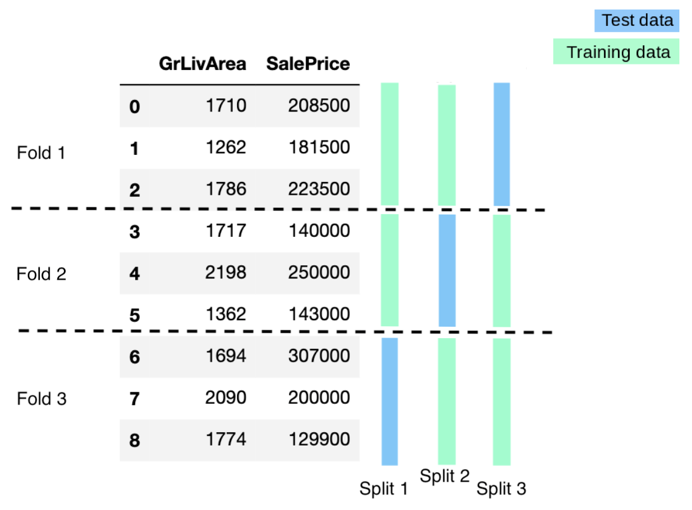

### **Cross validation in Scikit-Learn**

**from** **sklearn.model_selection** **import** cross_validate

cross_validate(model, X, y, cv = 5) *# returns test_score, fit_time and score_time*

### **Bias/Variance tradeoff**

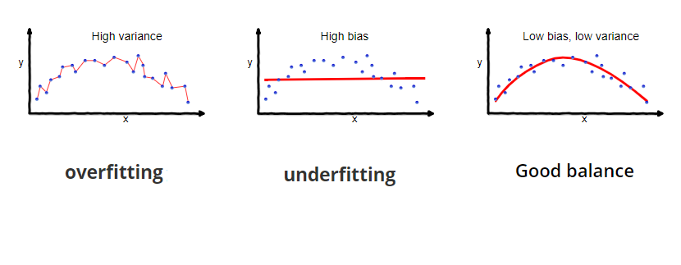

### **Learning Curves**

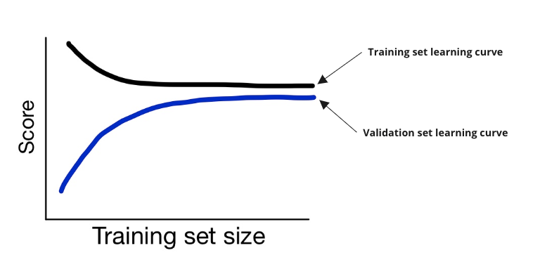

## **Plan of the lecture**

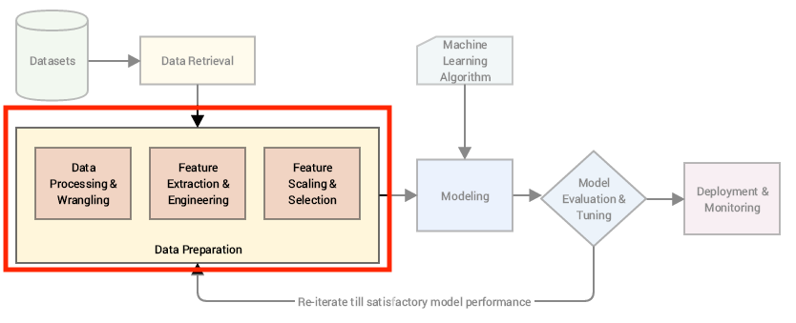

***General prerequisites***

(1) 👥 Duplicates

(2) 🔮 Missing data

(3) 🐳 Outliers

***Numerical columns***

(4) 🔢 Scaling

***Balanced datasets***

(5) ⚖️ Balancing

***Categorical columns***

(6) 🔠 Encoding

(7) 🟨 Discretizing

***Generating new features***

(8) 🟨 Feature creation

***Using the most relevant features***

(9) 🤖 Feature selection, Modelling and Feature Permutation

## **🛠 Why preprocessing?**

* Raw data is dirty and noisy
* Machine learning algorithms have certain constraints regarding input data
* Transformations can improve the model performance

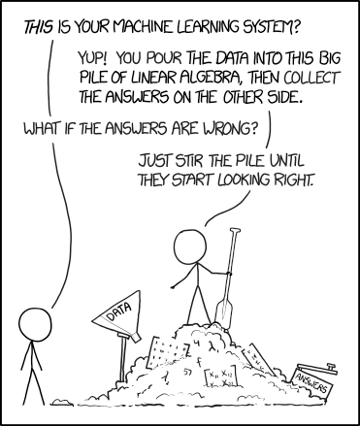

🔗 [Source](https://xkcd.com/1838/)

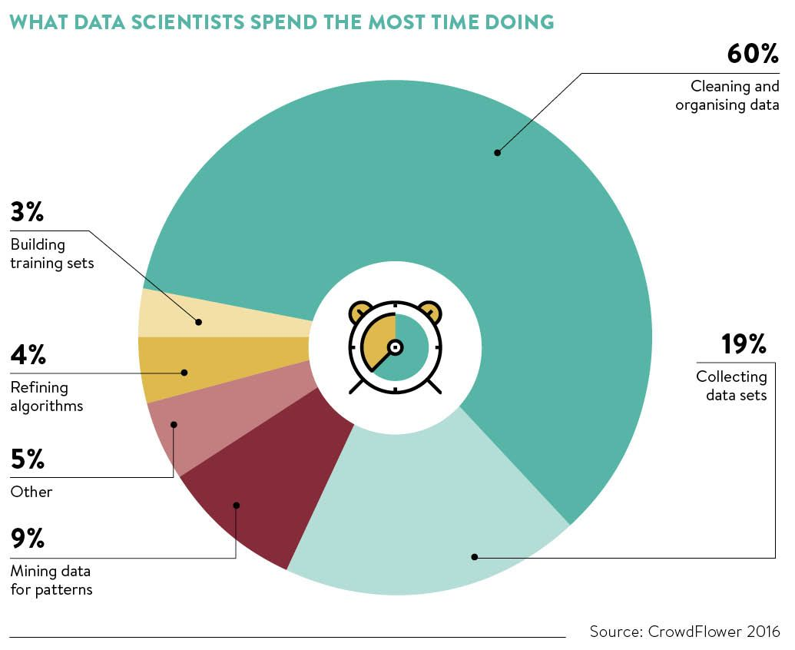

🔗 Source

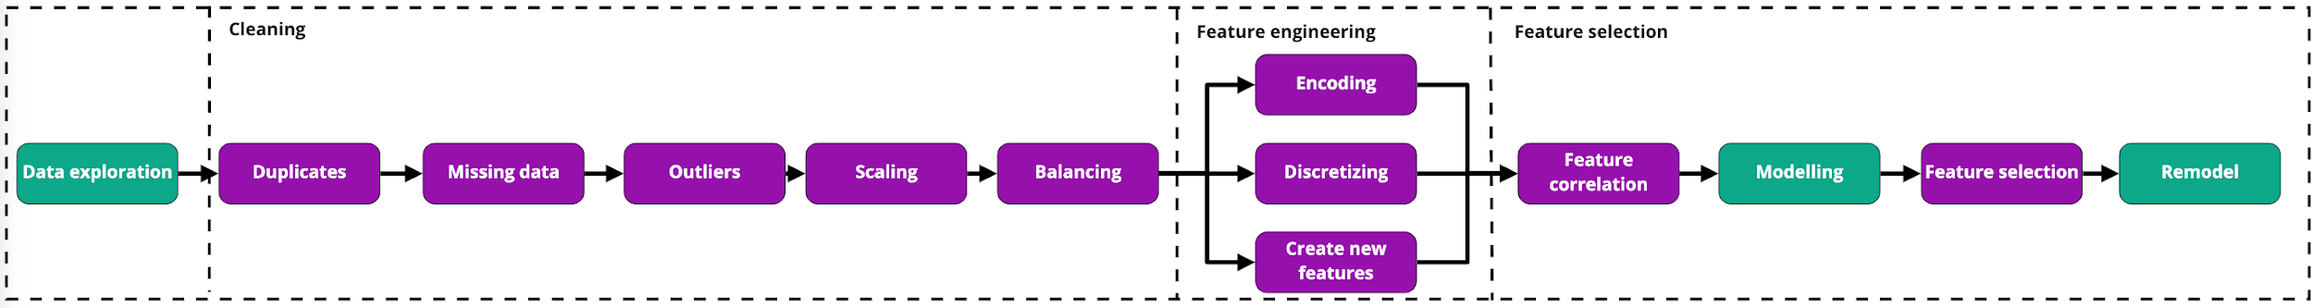

🏠 Let's consider the Houses dataset we used in the previous lecture 01 - Fundamentals of ML

👉 Now, we are going to include some new features in our modelling: Alley,Street, WallMat, Pesos, and MoSold.

* 💾 Download the dataset [here](https://wagon-public-datasets.s3.amazonaws.com/Machine%20Learning%20Datasets/ML_Houses_dataset.csv)
* ℹ️ Have a look at the full dataset description [here](https://wagon-public-datasets.s3.amazonaws.com/Machine%20Learning%20Datasets/ML_Houses_dataset_description.txt).

data.head()

|  | **GrLivArea** | **BedroomAbvGr** | **KitchenAbvGr** | **OverallCond** | **Pesos** | **Alley** | **Street** | **WallMat** | **SalePrice** |
| --- | --- | --- | --- | --- | --- | --- | --- | --- | --- |
| **0** | 1710 | 3 | 1 | 5 | 4170000.0 | NaN | Pave | Concrete | 208500 |
| **1** | 1262 | 3 | 1 | 8 | 3630000.0 | NaN | Pave | Wood | 181500 |
| **2** | 1786 | 3 | 1 | 5 | 4470000.0 | NaN | Pave | Wood | 223500 |
| **3** | 1717 | 3 | 1 | 5 | 2800000.0 | NaN | Pave | Concrete | 140000 |
| **4** | 2198 | 4 | 1 | 5 | 5000000.0 | NaN | Pave | Concrete | 250000 |

# **(1) 👥 Duplicates**

❓ Duplicated observations can discredit the performance evaluation of a model. Why ❓

data[["GrLivArea","SalePrice"]].head(10)

|  | **GrLivArea** | **SalePrice** |
| --- | --- | --- |
| **0** | 1710 | 208500 |
| **1** | 1262 | 181500 |
| **2** | 1786 | 223500 |
| **3** | 1717 | 140000 |
| **4** | 2198 | 250000 |
| **5** | 1362 | 143000 |
| **6** | 1694 | 307000 |
| **7** | 2090 | 200000 |
| **8** | 1774 | 129900 |
| **9** | 1077 | 118000 |

## **⚠️ Data Leakage**

* In order to evaluate a model's ability to generalize, **the data in the test set should remain unseen by the algorithm during the training phase**.
  + If there are **duplicated rows** present in ***both*** the **training set** and the **test** set, this can cause **unreliable scores**.

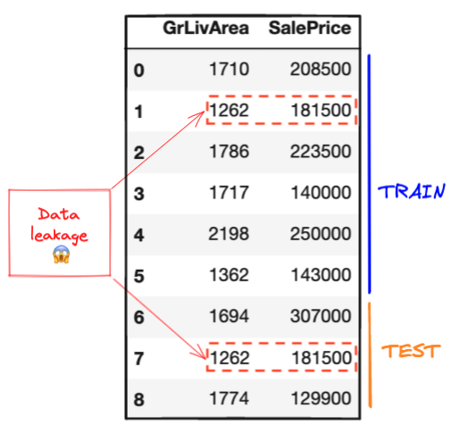

### **💻 drop_duplicates**

len(data) *# Check number of rows before removing duplicates*

1760

data.duplicated() *# Check whether a row is a duplicated version of a previous row*

0 False

1 False

2 False

3 False

4 False

...

1755 True

1756 True

1757 True

1758 True

1759 True

Length: 1760, dtype: bool

data.duplicated().sum() *# Compute the number of duplicated rows*

303

data = data.drop_duplicates() *# Remove duplicates*

len(data)*# Check new number of rows*

1457

# **(2) 🔮 Missing Data**

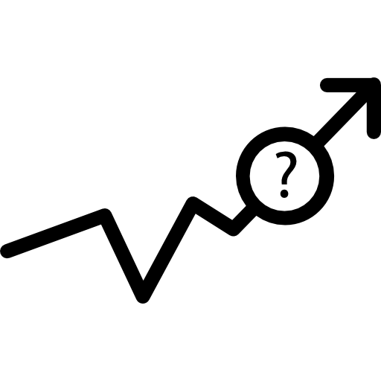

## **Common reasons for missing data**

* 🧑🏻‍💻 Programming error
* 😕 Failure of measurement (e.g. a patient in a clinical study misses a scheduled visit)
* 🎲 Random events (e.g. meteorological data collection device runs out of power)
* ❌ Incorrect text entries
* etc...

## **Common representations for missing data**

* NaN (*not a number*)
* 999 (*or any suspiciously large negative number...*)
* ?
* ±
* ∞
* (infinite values)
* "" (*Empty string*)

### **💻 Detecting missing data**

*# Counting the number of NaN for each column*

data.isnull().sum().sort_values(ascending=**False**)

WallMat 1452

Alley 1367

Pesos 10

GrLivArea 0

BedroomAbvGr 0

KitchenAbvGr 0

OverallCond 0

Street 0

SalePrice 0

dtype: int64

*# Counting the percentage of NaN for each column*

data.isnull().sum().sort_values(ascending=**False**) / len(data) *#NaN percentage for each column*

WallMat 0.996568

Alley 0.938229

Pesos 0.006863

GrLivArea 0.000000

BedroomAbvGr 0.000000

KitchenAbvGr 0.000000

OverallCond 0.000000

Street 0.000000

SalePrice 0.000000

dtype: float64

## **Handling missing data**

How you handle missing values will differ from field to field and dataset to dataset.

* What might have caused the missing values?
* Do the missing values represent a particular story or event?
* Can I replace them by another value?
* Can I afford to lose any data?

🚨Some of these questions require domain knowledge. Ensure you are aware of what each column truly represents before starting any machine learning task!

👉 You can download the description of the dataset that we will be playing with [here](https://wagon-public-datasets.s3.amazonaws.com/Machine%20Learning%20Datasets/ML_Houses_dataset_description.txt).

### **WallMat**

*# Percentage of missing values in WallMat*

(data.WallMat.isnull().sum() / len(data))

0.9965682910089224

*# 99% is way too high, let's drop this feature*

data = data.drop(columns='WallMat') *# Drop WallMat column*

data.head()

|  | **GrLivArea** | **BedroomAbvGr** | **KitchenAbvGr** | **OverallCond** | **Pesos** | **Alley** | **Street** | **SalePrice** |
| --- | --- | --- | --- | --- | --- | --- | --- | --- |
| **0** | 1710 | 3 | 1 | 5 | 4170000.0 | NaN | Pave | 208500 |
| **1** | 1262 | 3 | 1 | 8 | 3630000.0 | NaN | Pave | 181500 |
| **2** | 1786 | 3 | 1 | 5 | 4470000.0 | NaN | Pave | 223500 |
| **3** | 1717 | 3 | 1 | 5 | 2800000.0 | NaN | Pave | 140000 |
| **4** | 2198 | 4 | 1 | 5 | 5000000.0 | NaN | Pave | 250000 |

### **Alley**

*#Percentage of missing values in Alley*

(data.Alley.isnull().sum() / len(data))

0.938229238160604

🚨Missing data does not necessarily mean a lack of information!

👉 Here, you have to be careful. A *NaN* simply means that the house doesn't have an Alley.

**import** **numpy** **as** **np**

data.Alley = data.Alley.replace(np.nan, "NoAlley") *# Replace NaN by "NoAlley"*

data.Alley.value_counts() *# Check count of each category*

NoAlley 1367

Grvl 50

Pave 40

Name: Alley, dtype: int64

### **Pesos**

*# Percentage of missing values in Pesos*

(data.Pesos.isnull().sum() / len(data))

0.0068634179821551134

*# Option 1: Drop rows where Pesos value is missing*

data.dropna(subset=['Pesos'])

*# Option 2: Replace missing Pesos values with mean*

data.Pesos.replace(np.nan, data.Pesos.mean())

0 4170000.0

1 3630000.0

2 4470000.0

3 2800000.0

4 5000000.0

...

1455 3500000.0

1456 4200000.0

1457 5330000.0

1458 2842500.0

1459 2950000.0

Name: Pesos, Length: 1457, dtype: float64

### **💡Suggestions:**

* **More than 30%** of missing values
* →
* 🚮 Potentially drop the feature or the row
* **Less than 30%** of missing values
* →
* 💡 Consider an *imputer* with a strategy that makes sense (cf. next slides)

🚨 Keep in mind that imputing a missing value is an approximation. This can generate potential **noise** and/or **bias** for your models.

### **🖥 Sklearn's SimpleImputer**

With this tool called *SimpleImputer*, you can replace missing values with a strategy of your choice (e.g. median, mean, mode, most frequent, ...)

📚[**sklearn.impute.SimpleImputer**](https://scikit-learn.org/stable/modules/generated/sklearn.impute.SimpleImputer.html)

**from** **sklearn.impute** **import** SimpleImputer

*# Instantiate a SimpleImputer object with your strategy of choice*

imputer = SimpleImputer(strategy="mean")

*# Call the "fit" method on the object*

imputer.fit(data[['Pesos']])

*# Call the "transform" method on the object*

data['Pesos'] = imputer.transform(data[['Pesos']])

*# The mean is stored in the transformer's memory*

imputer.statistics_

array([3608796.22667588])

***How did the SimpleImputer work?***

imputer.fit()

1. imputer computes the strategy for the feature(s) it is being fitted on
2. stores the "strategic" value as an attribute

imputer.transform()

1. identifies missing values
2. replaces missing values with the strategic value calculated in the fit step

👨🏻‍🏫 In Scikit Learn, there are a couple of tools designed to help you prepare a dataset before feeding a Machine Learning model with the preprocessed data. They are called **scikit-learn transformers**

* **.fit()**: learns and stores constants as attributes of the transformer
* **.transform()**: uses these attributes to transform features of your choice from the original dataset

# **(3) 🐳 Outliers**



***Outliers are data points which deviate from the rest of the data.***

## **Common reasons for outliers**

* ⌨️ Data entry errors
* 📐 Measurement errors
* 🧑🏻‍🔬 Data manipulation and preprocessing errors
* 🆕 Novelties (not errors)

## **Outliers affect:**

* 🕵🏻‍♀️ Dataset distributions and patterns
* 🕵🏻‍♀️ Central tendency metrics such as the *mean* of a feature
* 🕵🏻‍♀️ Dispersion metrics such as *standard deviation*
* 🤖 Performance of a Machine Learning model

## **Detecting Outliers - Boxplot**

We can use ***boxplots*** to visualize outliers within a dataset.

data[['GrLivArea']].boxplot();

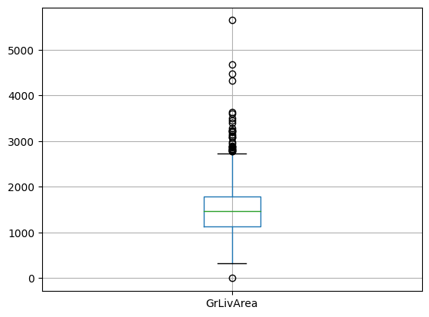

* 📚 [pandas.DataFrame.boxplot](https://pandas.pydata.org/docs/reference/api/pandas.DataFrame.boxplot.html)
* 📚 [matplotlib.pyplot.boxplot](https://matplotlib.org/stable/api/_as_gen/matplotlib.pyplot.boxplot.html)
* 📚 [seaborn.boxplot](https://seaborn.pydata.org/generated/seaborn.boxplot.html)

Are all the outliers "real outliers"❓

data['GrLivArea'].min()

-1

## **Handling Outliers**

* Is the outlier evidently false?
* Could it be a novelty?
* Could it be used as a feature?

🚨Outliers can be an opinion. We must fully comprehend what an outlier is before removing it from the dataset.

### **Dropping Outliers**

If data is evidently false: a house cannot have a living area of -1

f

t

2

.

data['GrLivArea'] == -1

0 False

1 False

2 False

3 False

4 False

...

1455 False

1456 False

1457 False

1458 False

1459 False

Name: GrLivArea, Length: 1457, dtype: bool

*# Save the indexes corresponding to rows*

*# without the absurd -1 value*

*# and without large mansions (>5000 ft)*

boolean_mask = (data['GrLivArea']>0) & (data['GrLivArea']<5000)

*# Apply the boolean filtering*

data = data[boolean_mask].reset_index(drop=**True**)

*# Visualize the boxplot again*

data[['GrLivArea']].boxplot();

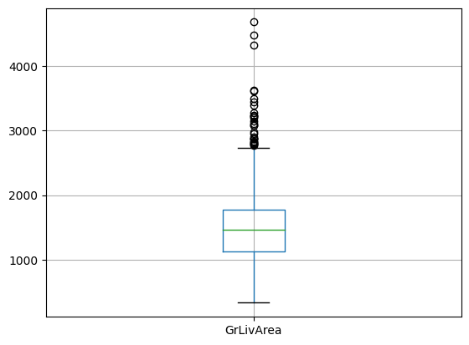

# **(4) 🔢 Feature Scaling**

🪜 ***Feature scaling is the process of transforming numerical features into a***

±

***common smaller range***

## **Why scaling?**

* ❗️ Features with large magnitudes can incorrectly outweigh features of small magnitudes
* ⚡️ Scaling to smaller magnitudes improves computational efficiency
* 🕵🏻‍♂️ Increases interpretability about the impact of each feature in a Machine Learning model

👇 Look at our dataset, which of these features are 🔢 numerical features?

data.head(3)

|  | **GrLivArea** | **BedroomAbvGr** | **KitchenAbvGr** | **OverallCond** | **Pesos** | **Alley** | **Street** | **SalePrice** |
| --- | --- | --- | --- | --- | --- | --- | --- | --- |
| **0** | 1710 | 3 | 1 | 5 | 4170000.0 | NoAlley | Pave | 208500 |
| **1** | 1262 | 3 | 1 | 8 | 3630000.0 | NoAlley | Pave | 181500 |
| **2** | 1786 | 3 | 1 | 5 | 4470000.0 | NoAlley | Pave | 223500 |

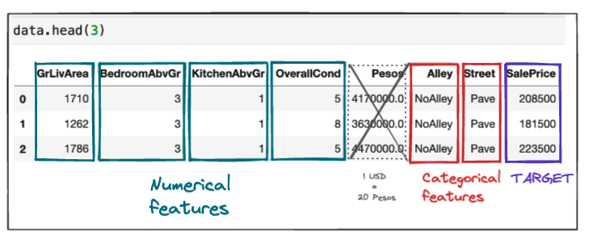

*Note: this conversion rate can evolve, let's use this one in the lecture*.

## **The most famous scalers**

1. **StandardScaler** ("Standardizing")
2. **MinMaxScaler** ("Normalizing")
3. **RobustScaler**

## **(4.1) Standardizing**

*[Math Processing Error]*

This operation will transform a feature so that its distribution is:

* centered around 0 (
* μ
* =
* 0
* )
* with a standard deviation equal to (
* σ
* =
* 1
* )

📚 [**sklearn.preprocessing.StandardScaler**](https://scikit-learn.org/stable/modules/generated/sklearn.preprocessing.StandardScaler.html)

### **The effect of standardization**

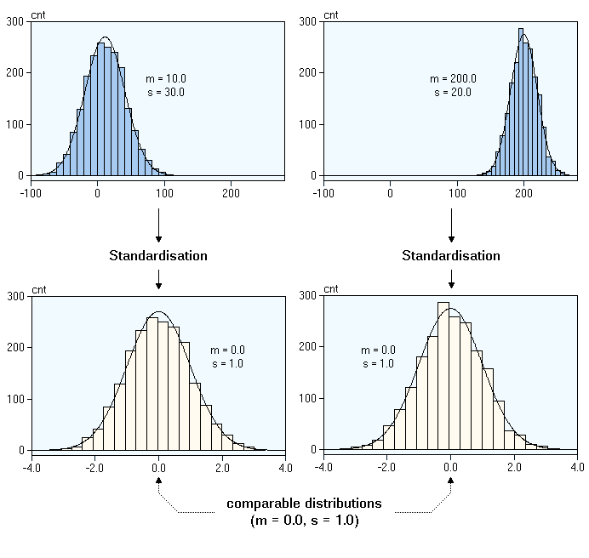

### **Standardization: Pros & Cons**

✅ Most efficient when a feature is normally distributed

🆗 Does not ensure an exact common range for two different features...

🆗 ...but overall, 99% of the values for a Gaussian-distributed feature are located within the interval

[

μ

−

3

σ

,

μ

+

3

σ

]

=

[

−

3

,

+

3

]

(after standardizing).

❗️ Sensitive to outliers...

❗️ Can distort relative distances between feature values...

## **(4.2) Normalizing**

*[Math Processing Error]*

👉 The feature values are compressed in a fixed range [0,1].

📚 [**sklearn.preprocessing.MinMaxScaler**](https://scikit-learn.org/stable/modules/generated/sklearn.preprocessing.MinMaxScaler.html)

### **MinMax Scaling effects and use cases:**

✅ Ensures a fixed range in

[

0

,

1

]

for all the values of a given feature

ℹ️ It neither reduces the effect of outliers nor changes skewness.

👉 Preserves matrix sparsity! (*a 0 remains 0 for a positive matrix*)

🚀 Go-to scaling for:

* Ordinal features (*e.g. Olist review score*)
* Positive features or sparse matrix (*for instance: pixel luminosity*)
* The KNearestNeighbors algorithm (*KNN*), a distance-based algorithm that we will learn during the Performance Metrics lecture *(*[*why?*](https://stats.stackexchange.com/questions/363889/which-type-of-data-normalizing-should-be-used-with-knn#:~:text=Standardization%2C%20on%20the%20other%20hand%2C%20does%20have%20many%20useful%20properties%2C%20but%20can%27t%20ensure%20that%20the%20features%20are%20mapped%20to%20the%20same%20range)*)*

### **Scaling effects**

### →

### ***StandardScaler* vs. *MinMaxScaler***

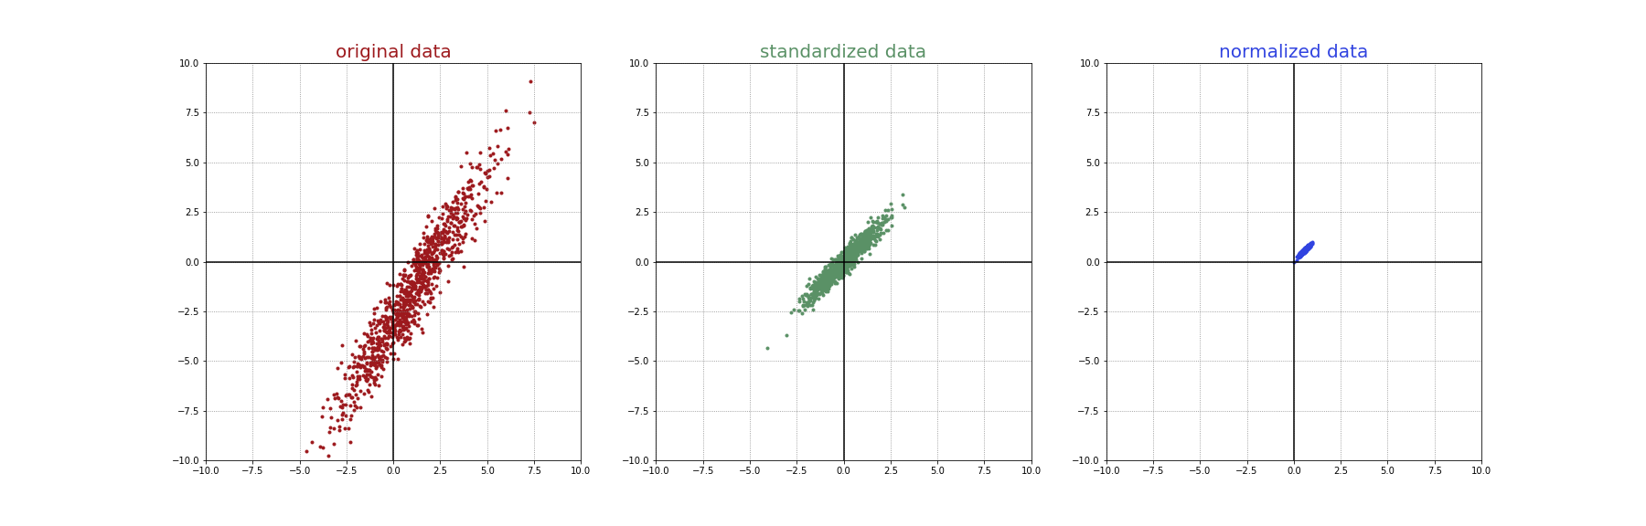

🧐 What if you're concerned with outliers?

### **(4.3) Robust Scaling**

✅ Robust Scaling uses:

* the median as central tendency metric
* the interquartile range
* I
* Q
* R
* =
* Q
* 3
* −
* Q
* 1
* as dispersion metric.

💪 Both of them are less sensitive to outliers than the mean and the standard deviation!

*[Math Processing Error]*

📚 [**sklearn.preprocessing.RobustScaler**](https://scikit-learn.org/stable/modules/generated/sklearn.preprocessing.RobustScaler.html)

## **(4.4) 🧑🏻‍💻 Scaling in practice with Scikit Learn**

👉 Let's scale the GrLivArea as an example.

What is the **distribution** of the GrLivArea feature ❓

**import** **seaborn** **as** **sns**

sns.histplot(data['GrLivArea'], bins=200,kde=**True**);

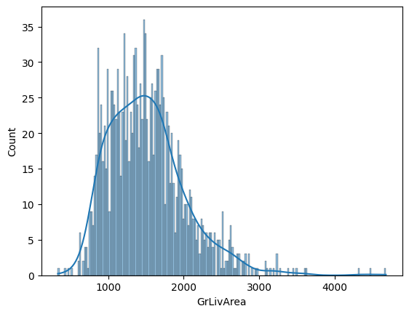

Does GrLivArea have outliers ❓

sns.boxplot(data=data, x='GrLivArea');

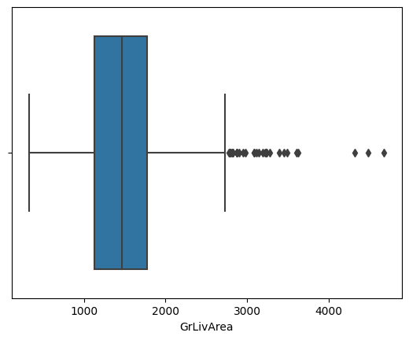

Which scaler should we apply to the GrLiveArea feature ❓

💻 **RobustScaler** applied to the GrLivArea

**from** **sklearn.preprocessing** **import** RobustScaler

*# Step 0 - Instantiate Robust Scaler*

rb_scaler = RobustScaler()

*# Step 1 - Fit the scaler to the `GrLiveArea`*

*# to "learn" the median value and the IQR*

rb_scaler.fit(data[['GrLivArea']])

*# Step 2 - Scale / Transform*

*# to apply the transformation (value - median) / IQR for every house*

data['GrLivArea'] = rb_scaler.transform(data[['GrLivArea']])

data.head()

|  | **GrLivArea** | **BedroomAbvGr** | **KitchenAbvGr** | **OverallCond** | **Pesos** | **Alley** | **Street** | **SalePrice** |
| --- | --- | --- | --- | --- | --- | --- | --- | --- |
| **0** | 0.380216 | 3 | 1 | 5 | 4170000.0 | NoAlley | Pave | 208500 |
| **1** | -0.312210 | 3 | 1 | 8 | 3630000.0 | NoAlley | Pave | 181500 |
| **2** | 0.497682 | 3 | 1 | 5 | 4470000.0 | NoAlley | Pave | 223500 |
| **3** | 0.391036 | 3 | 1 | 5 | 2800000.0 | NoAlley | Pave | 140000 |
| **4** | 1.134467 | 4 | 1 | 5 | 5000000.0 | NoAlley | Pave | 250000 |

## **(4.5) Rules of thumb when scaling 👍**

**Feature Transformation/Engineering**

* If your feature is extremely skewed
* →
* consider ***Feature Engineering*** first (*e.g. log(feature)*)

**Robust Scaler**

* If your feature transformation doesn't work
* →
* consider ***Robust Scaling*** this feature
* If your feature is still heavily skewed with outliers that (you assume to be) irrelevant
* →
* consider ***Robust Scaling***

**Standard Scaler**

* Otherwise, ***Standard Scaling*** is a safe bet.
  + Before doing a fine-grained selection of which scalers to use for each feature, you can run a model using only Standard Scaling to run the model quickly.
  + Models like Linear Regression and Neural Networks work quite well with zero-centered features.

**MinMax Scaler**

* If your features form a positive or sparse matrix (*e.g. RGB values in a picture between 0 and 255*)
* →
* consider ***MinMax Scaling***
* If you think that outliers (if any) are full part of the dataset and shouldn't be removed
* →
* consider ***MinMax Scaling***

All rules of thumb are subject to exceptions 🙃

# **(5) ⚖️ Dataset balancing**

* In a dataset, we also have to deal with categorical columns.
  + Depending on your task, they can be a 🔠 feature or a 🎯 target.
  + They need to be converted into numbers for the Machine Learning algorithm to understand them.
* Before turning classes into numbers, we need to ***check for ⚖️ class imbalance***.
  + 🦠 *Disease prevalence*
    - In epidemiology, prevalence is the proportion of a particular population found to be affected by a medical condition (typically a disease or a risk factor such as smoking or seatbelt use)
  + 🙋🏿‍♂️ *Race*
    - Ethnic groups being overrepresented/underrepresented in some contexts
    - Read [A. King & E. Puyol-Antón - AI Models can be racially biased](https://www.kcl.ac.uk/news/ai-models-can-be-racially-biased-when-trained-on-unbalanced-data-sets-researchers-find)
  + 💃🏼 *Gender*
    - Cf. [Focus2030 - Overview of data resources on gender equality cross the world](https://focus2030.org/Overview-of-data-resources-on-gender-equality-across-the-world)
  + 🛍️ *E-commerce - Conversion rate*:
    - Most users ignore the ads and only a small fraction will click on them.
  + 💳 *Banking - Credit card fraud detection*:
    - A vast majority of transactions are legitimate and only a small fraction are fraudulent.

## **Why balancing?**

* 🤝 Machine Learning algorithms learn by example
  + 😓 If a class is underrepresented enough, the model will tend to predict the under-represented class poorly
  + ⚖️ A 70/30 ratio (class A / class B) split for binary classification can be considered imbalanced

## **Balancing strategies**

* ***Oversampling*** of minority class
  + Alternatively, ***Computation of new instances*** for the minority class
* ***Undersampling*** of majority class

## **Oversampling or Undersampling**

* ***Oversampling*** = duplicating instances of the minority class
* ***Undersampling*** = sampling down the majority class

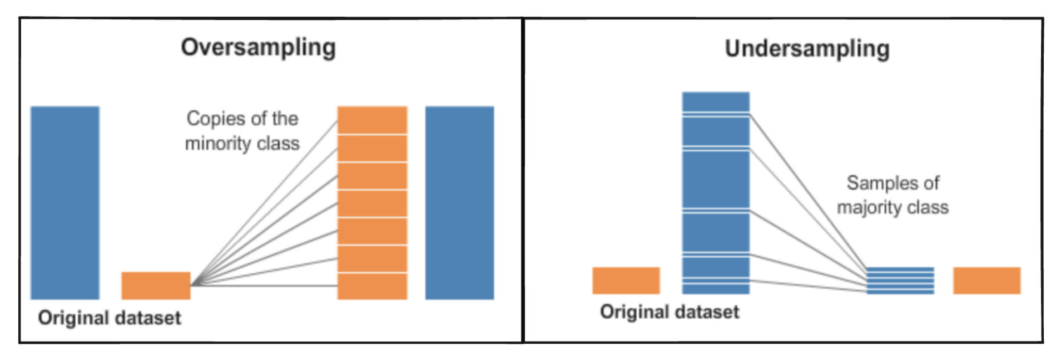

🔗 [Source](https://www.kaggle.com/rafjaa/resampling-strategies-for-imbalanced-datasets#t1)

❗️ ***Warning about the oversampling method*** ❗️

1. **Train**-**test** split your dataset *before* oversampling
2. **Oversample only in the train set**
3. →
4. *The model needs to learn about the minority class*
5. **Evaluate on the test set without oversampling**
6. →
7. *We want the model to be evaluated in real conditions*

## **Synthetic Minority Oversampling TEchnique (SMOTE)**

***SMOTE is an oversampling algorithm that generates new minority instances from existing minority instances - based on linear combinations of existing points.***



🔗 [Source](https://rikunert.com/SMOTE_explained)



📚 [SMOTE documentation](https://imbalanced-learn.org/stable/over_sampling.html#over-sampling)

ℹ️ Notice that you have to pip install imbalanced-learn

👉 Imbalanced-learn (imported as imblearn) is an open source, MIT-licensed library relying on scikit-learn (imported as sklearn) and provides tools when dealing with classification with imbalanced classes.

🚨 ***Be careful with balancing techniques*** 🚨

* Use balancing techniques only on the training set to help the model learn about the minority class.
* The test set should remain representative of the real world.

# **(6) 🔠 Encoding**

🔠 **Encoding consists in transforming non-numerical data into an equivalent numerical form.**

## **Why encoding?**

* 🔠 Data may be represented as words, letters, or symbols
* 🤖 Most Machine Learning algorithms only process numerical data

## **(6.1) Feature Encoding with *OrdinalEncoder***

***OrdinalEncoder assigns a number to each category.***

📚 [**sklearn.preprocessing.OrdinalEncoder**](https://scikit-learn.org/stable/modules/generated/sklearn.preprocessing.OrdinalEncoder.html)

👇 Look at the following feature *"classes"*.

example = pd.DataFrame({"classes":["bad", "average", "average", "good", "good", "bad", "good"]})

example

|  | **classes** |
| --- | --- |
| **0** | bad |
| **1** | average |
| **2** | average |
| **3** | good |
| **4** | good |
| **5** | bad |
| **6** | good |

🤔 How would a Machine Learning algorithm understand these classes?

👩🏿‍💻 Let's convert this column into numbers!

**from** **sklearn.preprocessing** **import** OrdinalEncoder

*# Instantiate the Ordinal Encoder*

ordinal_encoder = OrdinalEncoder()

*# Fit it*

ordinal_encoder.fit(example[["classes"]])

*# Display the learned categories*

display(ordinal_encoder.categories_)

*# Transform categories into ordered numbers*

example["encoded_classes"] = ordinal_encoder.transform(example[["classes"]])

*# Show the transformed classes*

example

[array(['average', 'bad', 'good'], dtype=object)]

|  | **classes** | **encoded_classes** |
| --- | --- | --- |
| **0** | bad | 1.0 |
| **1** | average | 0.0 |
| **2** | average | 0.0 |
| **3** | good | 2.0 |
| **4** | good | 2.0 |
| **5** | bad | 1.0 |
| **6** | good | 2.0 |

👆 We would expect something such as bad

↔

0, average

↔

1 and good

↔

2, right ?

💡 You can specify it in the Ordinal Encoder with categories

**from** **sklearn.preprocessing** **import** OrdinalEncoder

*# Instantiate the Ordinal Encoder*

ordinal_encoder = OrdinalEncoder(categories=[["bad","average","good"]])

*# Fit it*

ordinal_encoder.fit(example[["classes"]])

*# Display the learned categories*

display(ordinal_encoder.categories_)

*# Transform categories into ordered numbers*

example["encoded_classes"] = ordinal_encoder.transform(example[["classes"]])

*# Show the transformed classes*

example

[array(['bad', 'average', 'good'], dtype=object)]

|  | **classes** | **encoded_classes** |
| --- | --- | --- |
| **0** | bad | 0.0 |
| **1** | average | 1.0 |
| **2** | average | 1.0 |
| **3** | good | 2.0 |
| **4** | good | 2.0 |
| **5** | bad | 0.0 |
| **6** | good | 2.0 |

🤔 But what if we cannot rank the different categories?

🌲 Have a look at the following illustration:

* If we were to use the *OrdinalEncoder*, we would create a false relationship between the different types of trees.
* How do we overcome this problem?

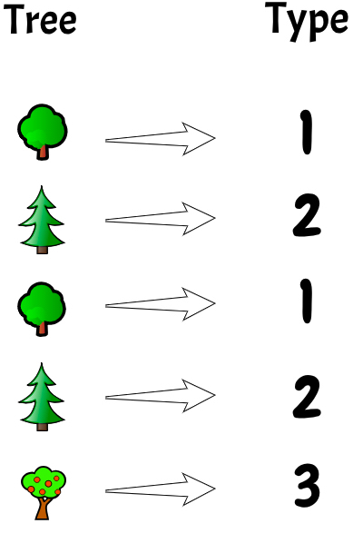

## **(6.2) Feature Encoding with *OneHotEncoder***

👉 Create a binary column for each possible category. This is also known as **One Hot Encoding**.

📚 [Sklearn OneHotEncoder() documentation](https://scikit-learn.org/stable/modules/generated/sklearn.preprocessing.OneHotEncoder.html)

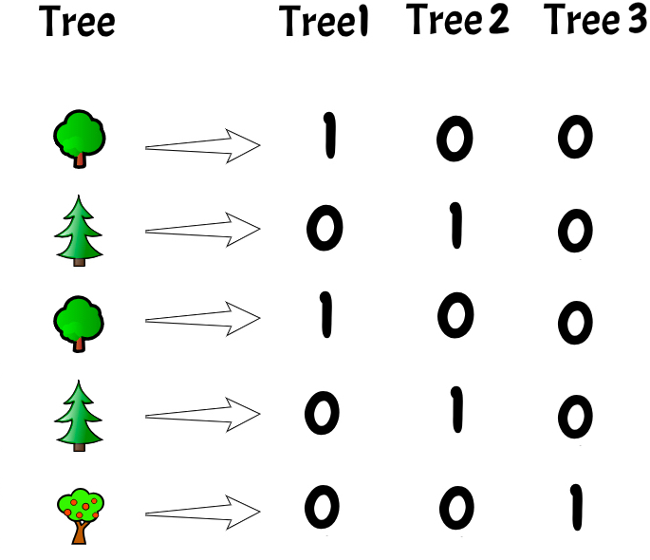

### **💻 One-hot-Encoding Alley**

**from** **sklearn.preprocessing** **import** OneHotEncoder

**import** **numpy** **as** **np**

*# Check unique values for streets (3)*

print(f"The unique values for 'Alley' are **{**data.Alley.unique()**}**")

*# Instantiate the OneHotEncoder*

ohe = OneHotEncoder(sparse_output=**False**)

*# Fit encoder*

ohe.fit(data[['Alley']])

*# Display the detected categories*

print(f"The categories detected by the OneHotEncoder are **{**ohe.categories_**}**")

The unique values for 'Alley' are ['NoAlley' 'Grvl' 'Pave']

The categories detected by the OneHotEncoder are [array(['Grvl', 'NoAlley', 'Pave'], dtype=object)]

*# Display the generated names*

print(f"The column names for the encoded values are **{**ohe.get_feature_names_out()**}**")

*# Transform the current "Alley" column*

data[ohe.get_feature_names_out()] = ohe.transform(data[['Alley']])

*# Drop the column "Alley" which has been encoded*

data = data.drop(columns=["Alley"])

*# Show the dataset*

data.head(3)

The column names for the encoded values are ['Alley_Grvl' 'Alley_NoAlley' 'Alley_Pave']

|  | **GrLivArea** | **BedroomAbvGr** | **KitchenAbvGr** | **OverallCond** | **Pesos** | **Street** | **SalePrice** | **Alley_Grvl** | **Alley_NoAlley** | **Alley_Pave** |
| --- | --- | --- | --- | --- | --- | --- | --- | --- | --- | --- |
| **0** | 0.380216 | 3 | 1 | 5 | 4170000.0 | Pave | 208500 | 0.0 | 1.0 | 0.0 |
| **1** | -0.312210 | 3 | 1 | 8 | 3630000.0 | Pave | 181500 | 0.0 | 1.0 | 0.0 |
| **2** | 0.497682 | 3 | 1 | 5 | 4470000.0 | Pave | 223500 | 0.0 | 1.0 | 0.0 |

### **💻 One-hot Encoding Street**

**from** **sklearn.preprocessing** **import** OneHotEncoder

*# Check unique values for streets (2)*

print(f"The unique values for 'Street' are **{**data.Street.unique()**}**")

*# Instantiate the OneHotEncoder*

ohe_binary = OneHotEncoder(sparse_output=**False**, drop="if_binary")

*# Fit encoder*

ohe_binary.fit(data[['Street']])

*# Display the detected categories*

print(f"The categories detected by the OneHotEncoder are **{**ohe_binary.categories_**}**")

The unique values for 'Street' are ['Pave' 'Grvl']

The categories detected by the OneHotEncoder are [array(['Grvl', 'Pave'], dtype=object)]

*# Display the generated names*

print(f"The column names for the encoded values are **{**ohe_binary.get_feature_names_out()**}**")

*# Transform the current "Street" column*

data[ohe_binary.get_feature_names_out()] = ohe_binary.transform(data[['Street']])

*# Drop the column "Street" which has been encoded*

data = data.drop(columns=["Street"])

*# Show the dataset*

data.head(3)

The column names for the encoded values are ['Street_Pave']

|  | **GrLivArea** | **BedroomAbvGr** | **KitchenAbvGr** | **OverallCond** | **Pesos** | **SalePrice** | **Alley_Grvl** | **Alley_NoAlley** | **Alley_Pave** | **Street_Pave** |
| --- | --- | --- | --- | --- | --- | --- | --- | --- | --- | --- |
| **0** | 0.380216 | 3 | 1 | 5 | 4170000.0 | 208500 | 0.0 | 1.0 | 0.0 | 1.0 |
| **1** | -0.312210 | 3 | 1 | 8 | 3630000.0 | 181500 | 0.0 | 1.0 | 0.0 | 1.0 |
| **2** | 0.497682 | 3 | 1 | 5 | 4470000.0 | 223500 | 0.0 | 1.0 | 0.0 | 1.0 |

## **(6.3) *LabelEncoder***

We talked about how to encode categorical features. But now...

🎯 What about a classification task where you would need to ***encode categorical targets***?

🐧 Let's say that we want to predict the species of penguins.

**import** **seaborn** **as** **sns**

penguins = sns.load_dataset("penguins")

penguins.head()

|  | **species** | **island** | **bill_length_mm** | **bill_depth_mm** | **flipper_length_mm** | **body_mass_g** | **sex** |
| --- | --- | --- | --- | --- | --- | --- | --- |
| **0** | Adelie | Torgersen | 39.1 | 18.7 | 181.0 | 3750.0 | Male |
| **1** | Adelie | Torgersen | 39.5 | 17.4 | 186.0 | 3800.0 | Female |
| **2** | Adelie | Torgersen | 40.3 | 18.0 | 195.0 | 3250.0 | Female |
| **3** | Adelie | Torgersen | NaN | NaN | NaN | NaN | NaN |
| **4** | Adelie | Torgersen | 36.7 | 19.3 | 193.0 | 3450.0 | Female |

target = penguins["species"]

target.value_counts()

Adelie 152

Gentoo 124

Chinstrap 68

Name: species, dtype: int64

📚 [**sklearn.preprocessing.LabelEncoder**](https://scikit-learn.org/stable/modules/generated/sklearn.preprocessing.LabelEncoder.html)

**from** **sklearn.preprocessing** **import** LabelEncoder

*# Instantiate the LabelEncoder*

label_encoder = LabelEncoder()

*# Fit it to the target*

label_encoder.fit(target)

*# Find the encoded classes*

print(f"The Label Encoder has encoded the penguin classes into **{**label_encoder.classes_**}**")

*# Transform the targets*

encoded_target = label_encoder.transform(target)

The Label Encoder has encoded the penguin classes into ['Adelie' 'Chinstrap' 'Gentoo']

*# Showing the target and the encoded target side by side*

pd.DataFrame({"target": target, "encoded_target": encoded_target}).sample(10)

|  | **target** | **encoded_target** |
| --- | --- | --- |
| **128** | Adelie | 0 |
| **275** | Gentoo | 2 |
| **215** | Chinstrap | 1 |
| **141** | Adelie | 0 |
| **131** | Adelie | 0 |
| **161** | Chinstrap | 1 |
| **265** | Gentoo | 2 |
| **50** | Adelie | 0 |
| **25** | Adelie | 0 |
| **314** | Gentoo | 2 |

💡 You can revert back to the original target:

original_target = label_encoder.inverse_transform(encoded_target)

*# Showing the encoded target and the original target side by side*

pd.DataFrame({"encoded_target": encoded_target, "original_target": original_target, "target": target}).sample(10)

|  | **encoded_target** | **original_target** | **target** |
| --- | --- | --- | --- |
| **302** | 2 | Gentoo | Gentoo |
| **154** | 1 | Chinstrap | Chinstrap |
| **279** | 2 | Gentoo | Gentoo |
| **134** | 0 | Adelie | Adelie |
| **332** | 2 | Gentoo | Gentoo |
| **85** | 0 | Adelie | Adelie |
| **99** | 0 | Adelie | Adelie |
| **293** | 2 | Gentoo | Gentoo |
| **261** | 2 | Gentoo | Gentoo |
| **95** | 0 | Adelie | Adelie |

Now, that was quite a tedious process 😩

💡 **Fortunately in most cases you don't have to encode and decode the targets!**

Most models in Scikit Learn can handle **targets** that have not been encoded.

These models handle the label encoding inside the model for us.

So, before you start encoding your targets (and decoding them back),  
**check if encoding is really needed!**First try your Scikit Learn model without encoding the targets, it will probably work.

📆 So where are we now ?

* ✅ (1) 👥 Duplicates
* ✅ (2) ⁉️ Missing data
* ✅ (3) 🐳 Outliers
* ✅ (4) 🔢 Feature scaling
* ✅ (5) 🔠 Encoding
* ✅ (6) ⚖️ Dataset balancing

👉 We need to talk about:

* 🟨 (7) Discretizing
* 🟨 (8) Feature creation

🔥 And the final and crucial section of this lecture:

* 🤖 (9) Feature selection, Modelling and Feature permutation

# **(7) 🟨 Discretizing**

**Discretizing is the process of turning continuous data into discrete data using bins.**

* 🧪 Performs feature engineering
* 🎯 Turns a regression task into a classification task

📚 [**Pandas cut() documentation**](https://pandas.pydata.org/pandas-docs/stable/reference/api/pandas.cut.html)

### **🖥 Discretizing Sale Price**

If we want to qualify a house as *Cheap* or *Expensive* for example, instead of predicting its price, we can prepare this dataset for a classification task.

Let's separate houses into either *Cheap* or *Expensive*, according to the average price of houses.

data['SalePriceBinary'] = pd.cut(x=data['SalePrice'],

bins=[data['SalePrice'].min()-1,

data['SalePrice'].mean(),

data['SalePrice'].max()+1],

labels=['cheap', 'expensive'])

data.head()

|  | **GrLivArea** | **BedroomAbvGr** | **KitchenAbvGr** | **OverallCond** | **Pesos** | **SalePrice** | **Alley_Grvl** | **Alley_NoAlley** | **Alley_Pave** | **Street_Pave** | **SalePriceBinary** |
| --- | --- | --- | --- | --- | --- | --- | --- | --- | --- | --- | --- |
| **0** | 0.380216 | 3 | 1 | 5 | 4170000.0 | 208500 | 0.0 | 1.0 | 0.0 | 1.0 | expensive |
| **1** | -0.312210 | 3 | 1 | 8 | 3630000.0 | 181500 | 0.0 | 1.0 | 0.0 | 1.0 | expensive |
| **2** | 0.497682 | 3 | 1 | 5 | 4470000.0 | 223500 | 0.0 | 1.0 | 0.0 | 1.0 | expensive |
| **3** | 0.391036 | 3 | 1 | 5 | 2800000.0 | 140000 | 0.0 | 1.0 | 0.0 | 1.0 | cheap |
| **4** | 1.134467 | 4 | 1 | 5 | 5000000.0 | 250000 | 0.0 | 1.0 | 0.0 | 1.0 | expensive |

# **(8) 🟨 Feature creation**

🧑🏻‍🔬 We can introduce some domain knowledge into a dataset in order to drive more signals for our models to learn!

### **Why create new features?**

* ➕ Create additional information
* 📈 Potentially improve model performance

### **Examples of creating new features**

* 🛌
* b
* e
* d
* r
* o
* o
* m
* t
* o
* t
* a
* l
* r
* o
* o
* m
* ratio
* 🏥
* B
* o
* d
* y
* M
* a
* s
* s
* I
* n
* d
* e
* x
* =
* h
* e
* i
* g
* h
* t
* w
* e
* i
* g
* h
* t
* 2
* 🛍️ delivered_date - dispatch_date for lag time between events
* 📆 Categorize date as either weekday or weekend

👨🏻‍🏫 Encoding, discretizing and creating new features fall under a category of preprocessing known as **feature engineering**.

👉 Scikit Learn has many more processing tools!

📚[**sklearn.preprocessing**](https://scikit-learn.org/stable/modules/classes.html#module-sklearn.preprocessing)

# **(9) 🤖 Feature selection, Modelling and Feature Permutation**

## **Prepare the dataset - All the steps**



🔎 [Click to zoom in](https://github.com/lewagon/data-images/raw/master/ML/preparation_steps.pdf)

**Feature selection is the process of eliminating "non-informative" features.**

👇 There are 2 main types of statistical feature selection:

* Univariate feature selection
* →
* ***Feature Correlation*** (Univariate)
* Multivariate
* →
* ***Features' multicollinearity*** (Multivariate)

## **(9.1) Why feature selection?**

* 🚮 Garbage in
* →
* garbage out
* 💥 The curse of dimensionality
* 🤯 Reducing complexity

### **🚮 Garbage in**

### →

### **garbage out**

Poor quality input will:

1. Induce noise
2. Destabilize the model
3. Generate unusable output

### **💥 The curse of dimensionality**

Not observing enough data to support a meaningful relationship.

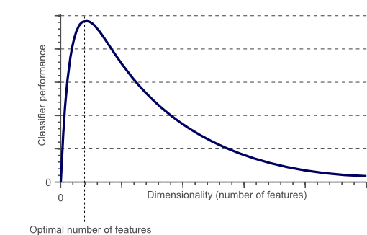

🔗[Source](https://www.visiondummy.com/2014/04/curse-dimensionality-affect-classification/)

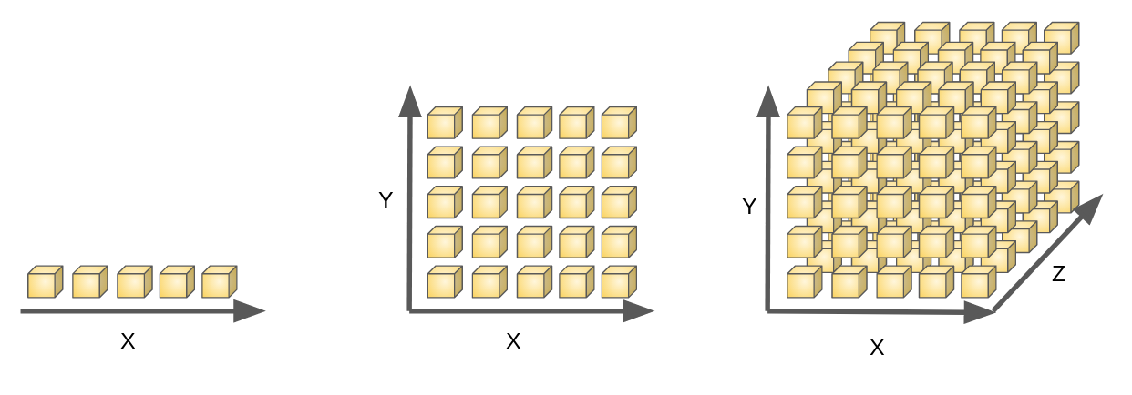

As the number of features or dimensions grows, the amount of data we need to generalize a model accurately grows **exponentially** e.g.

5

1

,

5

2

,

5

3

, ...,

5

n

.

🔗[More detail](https://livebook.manning.com/concept/r/dimensionality)

🚨 ***Warning about OneHotEncoder: be careful about which features you encode!***

* High variations within a categorical feature will generate more binary columns...
  + Consequently, you would need more data points
  + *Spoiler* : this is called ["Curse of dimensionality"](https://en.wikipedia.org/wiki/Curse_of_dimensionality)

## **(9.2) Feature correlation**

👩‍🏫 One of the feature selection techniques is to remove one of two features that are highly correlated to each other.

❗️ High correlation between feature

A

and feature

B

→

redundant information.

### **🖥 Pearson Correlation**

**import** **seaborn** **as** **sns**

*# Heatmap of pairwise correlations*

correlation_matrix = data.select_dtypes('number').corr()

column_names = correlation_matrix.columns

sns.heatmap(correlation_matrix, xticklabels=column_names, yticklabels=column_names,cmap= "bwr");

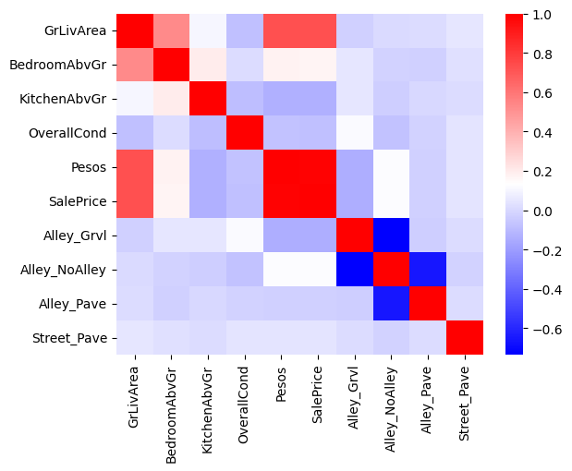

📚 [**matplotlib > colors > colormaps**](https://matplotlib.org/stable/tutorials/colors/colormaps.html)

Let's turn the correlation matrix into a DataFrame.

*# Convert the correlation matrix into a DataFrame*

corr_df = correlation_matrix.stack().reset_index()

*# Rename the columns*

corr_df.columns = ['feature_1','feature_2', 'correlation']

*# Remove "self correlations"*

no_self_correlation = (corr_df['feature_1'] != corr_df['feature_2'])

corr_df = corr_df[no_self_correlation]

Let's see which pairs of features are the most correlated (both positively and negatively)

*# Compute the absolute correlation*

corr_df['absolute_correlation'] = np.abs(corr_df['correlation'])

*# Show the top 5 most correlated pairs of feature*

corr_df.sort_values(by="absolute_correlation", ascending=**False**).head(5*2)

|  | **feature_1** | **feature_2** | **correlation** | **absolute_correlation** |
| --- | --- | --- | --- | --- |
| **54** | SalePrice | Pesos | 0.990353 | 0.990353 |
| **45** | Pesos | SalePrice | 0.990353 | 0.990353 |
| **76** | Alley_NoAlley | Alley_Grvl | -0.734669 | 0.734669 |
| **67** | Alley_Grvl | Alley_NoAlley | -0.734669 | 0.734669 |
| **50** | SalePrice | GrLivArea | 0.725634 | 0.725634 |
| **5** | GrLivArea | SalePrice | 0.725634 | 0.725634 |
| **40** | Pesos | GrLivArea | 0.724702 | 0.724702 |
| **4** | GrLivArea | Pesos | 0.724702 | 0.724702 |
| **87** | Alley_Pave | Alley_NoAlley | -0.654782 | 0.654782 |
| **78** | Alley_NoAlley | Alley_Pave | -0.654782 | 0.654782 |

💡 Hints:

* Remove as many of the "redundant" columns as you want, starting from those with the highest correlation.
* Keep doing it until your model's performance starts to drop significantly. At this point, you may have dropped too many features.

❓ Which pair of columns has the highest correlation ❓

The 🔢 feature Pesos is perfectly correlated to the 🎯 target SalePrice.

👀 What are we observing?

### **⚠️ Data Leakage**

💵 SalePrice USD

∼

20

×

Pesos (🔗 [xe.converter/USD-to-MXN](https://www.xe.com/currencyconverter/convert/?Amount=1&From=USD&To=MXN))

🚮 We should drop the column Pesos

data = data.drop(columns=['Pesos'])

## **(9.4) 🖥 Modelling 🥳**

👩🏼‍💻 Now that we have preprocessed our dataset, let's evaluate a classification model, the [Logistic Regression](https://kitt.lewagon.com/camps/1917/lectures/content/sklearn.linear_model.LogisticRegression).

data.head()

|  | **GrLivArea** | **BedroomAbvGr** | **KitchenAbvGr** | **OverallCond** | **SalePrice** | **Alley_Grvl** | **Alley_NoAlley** | **Alley_Pave** | **Street_Pave** | **SalePriceBinary** |
| --- | --- | --- | --- | --- | --- | --- | --- | --- | --- | --- |
| **0** | 0.380216 | 3 | 1 | 5 | 208500 | 0.0 | 1.0 | 0.0 | 1.0 | expensive |
| **1** | -0.312210 | 3 | 1 | 8 | 181500 | 0.0 | 1.0 | 0.0 | 1.0 | expensive |
| **2** | 0.497682 | 3 | 1 | 5 | 223500 | 0.0 | 1.0 | 0.0 | 1.0 | expensive |
| **3** | 0.391036 | 3 | 1 | 5 | 140000 | 0.0 | 1.0 | 0.0 | 1.0 | cheap |
| **4** | 1.134467 | 4 | 1 | 5 | 250000 | 0.0 | 1.0 | 0.0 | 1.0 | expensive |

**from** **sklearn.preprocessing** **import** LabelEncoder, MinMaxScaler

**from** **sklearn.linear_model** **import** LogisticRegression

**from** **sklearn.model_selection** **import** cross_val_score

*# Encode the target*

target_encoder = LabelEncoder().fit(data['SalePriceBinary'])

y = target_encoder.transform(data['SalePriceBinary'])

*# Define the features*

X = data.drop(columns=['SalePrice', 'SalePriceBinary'])

*# Scale numerical features*

*# Notice that we already RobutScaled GrLivArea*

minmax_scaler = MinMaxScaler()

X[["BedroomAbvGr","KitchenAbvGr","OverallCond"]] = minmax_scaler.fit_transform(X[["BedroomAbvGr","KitchenAbvGr","OverallCond"]])

*# Instantiate a model*

log_reg = LogisticRegression(max_iter=1000)

*# Score on multiple folds aka Cross Validation*

scores = cross_val_score(log_reg, X, y, cv=10)

scores.mean()

0.8308455361360416

### **⚠️ Data Leakage**

* ≥
* 0.80 seems like a good accuracy score...
* →
* If we have 100 houses, we are able to classify ~80 of them correctly.
* But actually, we have just committed the sin of data leakage, can you say which one and why?

🚨 **One should never apply transformations on the entire dataset!** 🚨

***☠️ Why should you scale the numerical features only on the training set?***

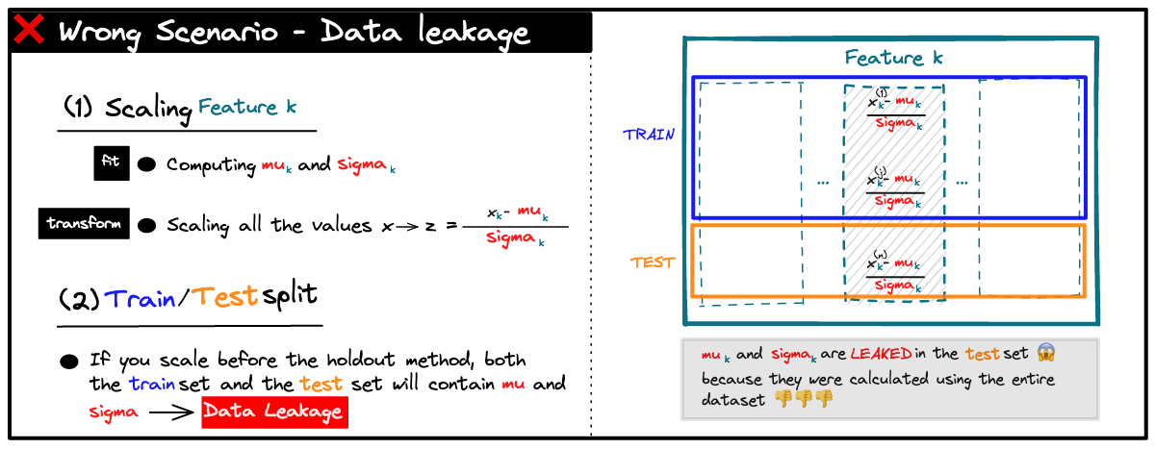

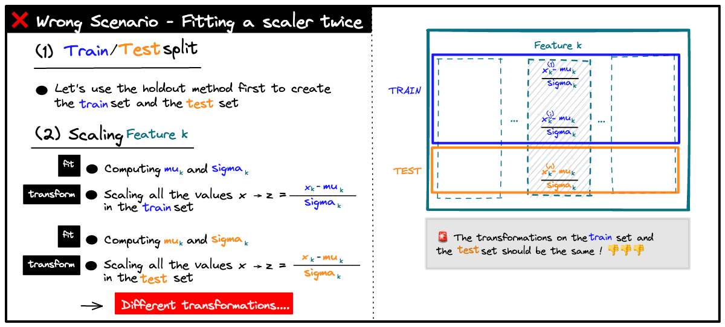

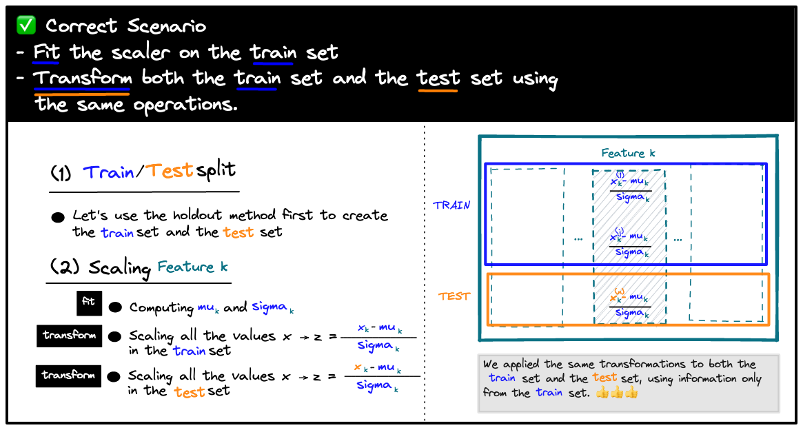

🚨 *The problem is that we scaled before doing a train-test split for each of the 5 submodels of the cross validation...*

🤔 *How to prevent data leakage derived from scaling during CV*❓

*How to prevent data leakage derived from scaling during CV?*

**Option 1: Manual K-fold Cross Validation**

1. Split your dataset into folds
2. Run a for loop with the following steps:
   * Define X_train, X_val, y_train, y_val
   * Fit your scaler on the train set
   * Transform both your train set and your validation set
   * Train your model on the train set
   * Evaluate it on the validation set

👩🏼‍💻 This manual K-fold Cross-Validation is tedious, boring, but easy to code.

🔗 See this [gist](https://gist.github.com/1fd64f3dfb9bec3a9cea179e6642443a)

*How to prevent data leakage derived from scaling during CV?*

**Option 2: Pipelines**

* Cf. Machine Learning > Unit 6 - Workflow

## **(9.5) 🃏 Feature Permutation**

***Feature Permutation is a feature selection "algorithm" which evaluates the importance of each feature in predicting the target.***

*How does Feature Permutation work?*

1️⃣ 🥋 **Trains** a base model containing all the features and **records the test score**.

2️⃣ 🎲 Permutation randomly **shuffles a feature** within the **test** set.

3️⃣ 🆕 **Records the new score on the test set** with the **shuffled feature**

4️⃣ 🕵🏻 Compares the new score to the original score. If the score dropped significantly, it means that this feature is important and that we shouldn't have shuffled it!

5️⃣ 🔁 Repeat steps 2-3-4 for each feature.

📚 [**sklearn.inspection.permutation_importance**](https://scikit-learn.org/stable/modules/generated/sklearn.inspection.permutation_importance.html)

### **💻 Feature permutation in Sklearn**

* Score without Permutation:

**from** **sklearn.model_selection** **import** cross_val_score

*# Model to be cross-validated*

log_model = LogisticRegression()

*# Cross Validation*

np.mean(cross_val_score(log_model, X, y , cv=5))

0.829553264604811

* Permutation:

**from** **sklearn.inspection** **import** permutation_importance

*# Fit model*

log_model = LogisticRegression().fit(X, y)

*# Perform the permutation*

permutation_score = permutation_importance(log_model, X, y, n_repeats=10)

*# Unstack results showing the decrease in performance after shuffling features*

importance_df = pd.DataFrame(np.vstack((X.columns,

permutation_score.importances_mean)).T)

importance_df.columns=['feature','score decrease']

*# Show the important features*

importance_df.sort_values(by="score decrease", ascending=**False**)

|  | **feature** | **score decrease** |
| --- | --- | --- |
| **0** | GrLivArea | 0.299863 |
| **1** | BedroomAbvGr | 0.025842 |
| **2** | KitchenAbvGr | 0.013265 |
| **5** | Alley_NoAlley | 0.010241 |
| **4** | Alley_Grvl | 0.004742 |
| **3** | OverallCond | 0.003918 |
| **7** | Street_Pave | 0.000687 |
| **6** | Alley_Pave | -0.000687 |

* Model with the strongest features:

*# Selecting the strongest features*

strongest_features = X[["GrLivArea", "BedroomAbvGr"]]

*# Re-instantiating a Logistic Regression*

log_reg = LogisticRegression()

*# Average accuracy of the cross-validated model*

np.mean(cross_val_score(log_reg, strongest_features, y, cv=10))

0.8136419461502126

## **(9.6) Reducing Complexity**

* A few words about complexity:
  + A complex model (in terms of features and/or algorithms) is not always the best solution
  + Trust the 20/80 [**Pareto Law**](https://en.wikipedia.org/wiki/Pareto_principle)
* Reducing the number of features makes the model:
  + More interpretable
  + Faster to train
  + Easier to implement and maintain in production

# **Prepare the dataset - Wrap up**



🔎 [Click to zoom in](https://github.com/lewagon/data-images/raw/master/ML/preparation_steps.pdf)

🚨 Whatever steps and strategies we choose to prepare the training set, we must apply exactly the same **transformations** to the test set, or to any new data point we want our model to predict.

🚨 Do not fit scalers/encoders on the test data! Use the learnings from fitting on the train set!

*# Instantiate your Scaler or your Encoder*

transformer = Transformer()

*# Fit it on the training set (or on specific columns)*

transformer.fit(X_train)

*# Apply the same transformations to both the train set and the test set*

X_train_transformed = transformer.transform(X_train)

X_test_transformed = transformer.transform(X_test)

🚨 When preparing a dataset, we **introduce human biases**.

* We preprocess it using strategies we believe to be the best possible strategies.
* This can be *harmful and non-inclusive* even if we didn't have bad intentions!

# **Your Turn! 🚀**